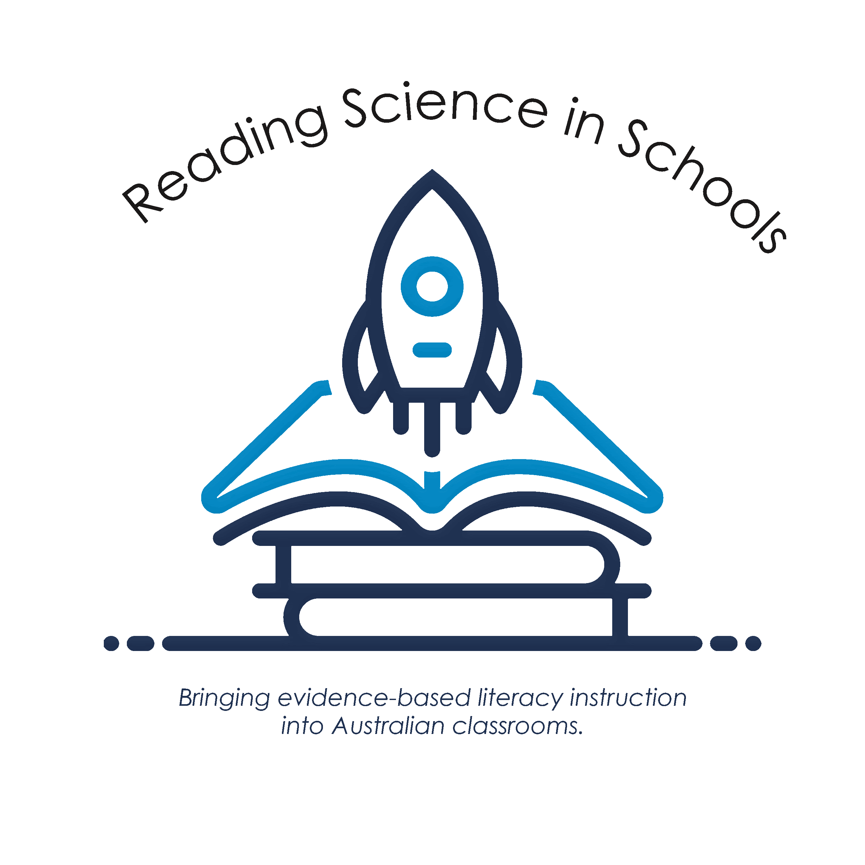

Follow us on Facebook for the latest version of all resources
Syntax Scope & Sequence- 2022
Explicit Teaching Sequence Kindergarten – Year 6

“Writing and reading are related”
Research has shown that when students receive writing instruction, their reading fluency and comprehension improve.
This scope and sequence should be used with the text The Writing Revolution (TWR) (Hochman & Wexler, 2017).

The Key Reading Comprehension Strategies (Oakhill, Cain, Elbro 2015) (Rosenshine & Meister 1993)

- Building vocabulary and background knowledge.

- Knowledge of sentence structure and how to make connections between sentences and paragraphs.

- Knowledge of text structure and text types (genres).

- Inferencing skills.

- Self-monitoring of comprehension/questioning.

- Summarisation.

The Writing Revolution Principles (Hochman & Wexler, 2017)

- Students need explicit instruction in writing, beginning in the early years.

- Sentences are the building blocks of all writing.

- When embedded into the content learning areas of the curriculum, writing instruction is a powerful teaching tool.

- The content of the curriculum should drive the writing activities.

- Grammar is best taught in context of student writing.

- The two most important phases of writing process are planning and revising.

Simple View of Writing

(Berninger & Amtmann, 2003)

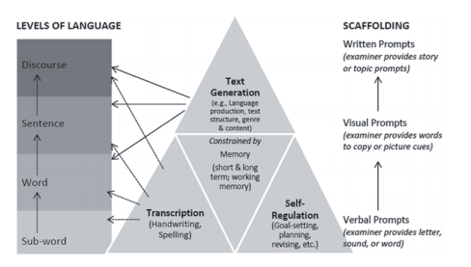

Recommended books to use with the K-6 Sentence Scope and Sequence:
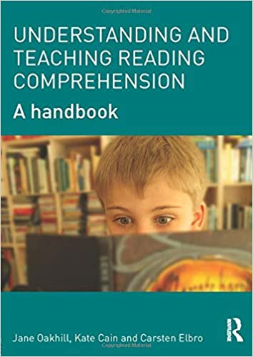
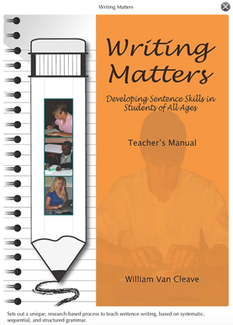
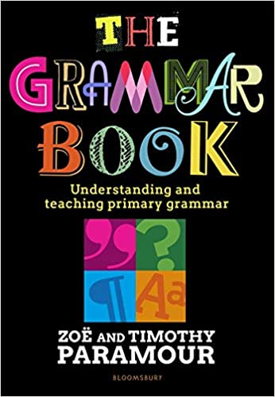
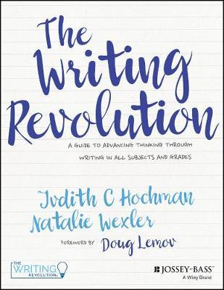

I Do Whole Class
Teach/revise concepts/types of sentence/sentence strategy.
Compose and analyse sentences with ‘think aloud’.
Teach grammar terminology e.g. noun, verb, sentence, fragment etc.
Teach and highlight punctuation.
Provide examples and non-examples.
Break sentences into parts. Discuss and analyse parts.
Incorporate Tier 2 vocabulary instruction.
Use sentences from literature/theme work/HaSS/Science/Health.

We Do Whole Class/Small Group
Revise key teaching points.
Co construct/modify sentences.
Innovate and change parts of sentences with student suggestions orally and in written form.
Provide options for students if required.
Provide deliberate practice opportunities for students working with teacher guidance and/or in small groups/pairs.
Teachers provide feedback and guide corrections.

You Do Individual/Small Group
Revise key teaching points.
Students modify, construct, generate sentences on own orally and in written form.
Students share sentence work with class.
Teachers provide feedback.

Explicit Teaching of Sentence Structure
Instructional Model
TWR strategies should be done in sequence but total mastery isn’t necessary before moving onto another strategy. It is important to keep circling back and reviewing previously taught strategies. For a complete list of strategies, see The Writing Revolution (Hochman & Wexler, 2017)

Syntax Scope and Sequence K-2
O-=Orally | Sentence Knowledge | Sentence Composition | Punctuation | Word Knowledge
Kindergarten | - Repeat phrases and sentences O  - Count/clap words in sentences O | - Sentence completion tasks O  - Ask and answer questions using simple sentences O  - Compose sentences and phrases to express ideas and needs O  - Guide students to expand simple sentences by including more information: who, what, where, when, how. O  - Guide students to expand sentences using additional describing words (adjectives, adverbs), adding conjunctions -because, after, then etc O | - Exposure to capital letters especially for names | - Concept of a word (as opposed to sound, letter. sentence)
Foundation/  Pre-Primary | - Identify fragments and sentences  - Identify sentence types: statement or question | - Convert fragments into sentences  - Expand simple sentences (kernels) by including more information: what, where, when, who  - Expand sentences using additional describing words (adjectives)  - Complete but, because, so sentences from sentence stems  (I woke up late, but…) – compound sentence  ( I woke up late, so…)- compound sentence  - Complete sentences when provided with a sentence stem containing a subordinate conjunction ‘before’, ‘after’ | - Capital letters for beginning of sentence & names  - Ending punctuation:  - Full stops | - Nouns and verbs  - Adjectives  - Conjunctions- and, but, because, before, after, if, when
Year 1 | - Identify fragments and sentences  - Identify all sentence types: statement, command, question, exclamation  - Identify subject & verb of a clause/sentence  - Unscramble statements- bolded first word | - Convert fragments to sentences  - Sentence expansion (who, what, when, where, why, how)  - Complete but, because, so sentences from sentence stems  (I woke up late, but…) – compound sentence  ( I woke up late, so…)- compound sentence  (I woke up late because… )- complex sentence  - Expand sentences using adjectives and adverbs.  - Complete sentences when provided with a sentence stem containing a subordinate conjunction ‘before’, ‘after’, ‘if’, ‘when’  - Develop questions given a picture or text material (who, what, where, when)  - Combine 2 sentences using a conjunction (compound subject & compound predicate)  - Develop statements, questions, commands and exclamations based on a picture/text | - Capital letters (Sentence and Proper Nouns)  - Ending punctuation:  - Full stops  - Question marks  - Exclamation marks | - Types of nouns: common, proper, pronouns  - Verbs  - Adjectives and adverbs  - Conjunctions- and, but, because, so, before, after, if, when  - Subject (the doer)  - Past tense (verbs)  - Plural (nouns)
Year 2 | - Identify fragments and sentences  - Identify all sentence types: statement, command, question, exclamation  - Identify subject & predicate of a clause/sentence  - Unscramble all sentence types  Paragraphs:  - Identify topic sentences  - Identify supporting details  - Identify concluding sentence | - Convert fragments to sentences  - Sentence expansion (who, what, when, where, why, how)  - Complete but, because, so sentences  (I woke up late, but…) – compound sentence  ( I woke up late, so…)- compound sentence  (I woke up late because… )- complex sentence  - Expand sentences using adjectives and adverbs  - Complete sentences when provided with a sentence stem containing a subordinate conjunction ‘before’, ‘after’, ‘if’, ‘when’ ‘even though’ ‘although’ ‘since’ ‘whenever’  - Combine 2-3 sentences  Paragraphs:  - Build (we do) single paragraph outlines (SPO) for narratives and expository texts  - Generate topic sentences (from key words and phrases)  - Select details that support topic sentences  - Use transitions to link sentences e.g. first, second, next, finally, in the end, although | - Capital letters (Sentence and Proper Nouns)  - Ending punctuation:  - Full stops  - Question marks  - Exclamation marks  - Commas for lists | - Types of nouns: common, proper  - Types of pronouns: personal, subject, object, possessive  - Types of verbs: action & mental  - Types of adverbs: manner, place, time  - Modal verbs and adverbs  - Conjunctions- and, but, because, so, before, after, if, when, even though, although, since, whenever  - Regular and irregular past tense (verbs)  - Regular and irregular plural (nouns)

Syntax Scope and Sequence 3-6
Year Level | Sentence Knowledge | Sentence Composition | Punctuation | Word Knowledge
Year 3 | - Consolidate Yr 2 sentence knowledge  - Identify subject and predicate within a clause  - Identify dependent and independent clauses within a sentence  Paragraphs:  - Identify topic sentences  - Identify supporting details  - Identify concluding sentence  - Identify transition words | - Consolidate Yr 2 sentence composition  - Complete but, because, so sentences from sentence stems (but + so are coordinating conjunctions so use a comma, because is a subordinating conjunction so no comma)  (I woke up late, but…)  ( I woke up late, so…)  (I woke up late because… )  - Expand sentences using adverbial phrase:  (Without a sound, the boy little girl crept down the hall)  - Create compound sentences using coordinating conjunctions and, but, so, or (comma before the coordinating conjunction to separate independent clauses)  (I woke up late, so I missed the bus)  - Create complex sentences using subordinate conjunctions to separate clauses (e.g. whenever, even though, although, since, because)  ID – no comma when independent clause precedes dependent clause*  (It starts to rain whenever I go for a walk)  D, I – comma when dependent clause precedes independent clause*  (Whenever I go for a walk, it starts to rain)  - Combine two sentences using an appositive and a pronoun (e.g. The Prime Minister of Australia visited Japan. The Prime Minister is Anthony Albanese.--> Anthony Albanese, the Prime Minister of Australia, visited Japan.)  - Sentence combining of 2 and 3 sentences  - Identify and correct errors in verb tense  Paragraphs:  - Improve and develop topic and concluding sentences using the strategies of sentence types, appositives and subordinating conjunctions  - Create sentences containing transition words and phrases to indicate: time and sequence, conclusion, illustration, change of direction and emphasis (see The Writing Revolution for complete list of transition words)  - Revising and editing an unelaborated paragraph  - Outlining and then drafting and revising paragraphs for different text types. | - Consolidate Yr 2 punctuation  - Capital letters (Sentence and Proper Nouns)  - Ending punctuation:  - Full stops  - Question marks  - Exclamation marks  - Commas for lists  - Comma usually after an adverbial/ adverbial phrase at the beginning of a sentence (fronted adverbial)  - Commas to separate clauses – placed here in this scope and sequence, but * students are not expected to consistently use until Year 6 as per the Australian Curriculum  - Word contractions for apostrophes (e.g. haven’t have not)  - Quotation marks – placed here in this scope and sequence, but students are not expected to consistently use until Year 4 as per the Australian Curriculum | - Consolidate Yr 2 word knowledge  - Types of pronouns: reflexive  - Types of verbs: action, speaking, mental  - Types of adverbs: manner, place, time, frequency  - Appositives  - Determiners (including articles, possessive adjectives and demonstratives).  - Coordinating conjunctions: and, but, so, or  - Subordinating conjunctions: start with subordinating conjunctions depicting time (e.g. after, when), cause (e.g. because), and concession (e.g. although).  - Transition words- (see The Writing Revolution for complete list of transition words)
Year 4 | - Consolidate Yr 1 - 3 sentence knowledge  - Identify dependent and independent clauses within a sentence  - Identify run-on sentences within a passage.  Paragraphs:  - Identify topic sentences  - Identify supporting details  - Identify concluding sentence  - Identify transition words | - Consolidate Yr 1 -3 sentence composition  - Correct run-on sentences.  - Create compound sentences using coordinating conjunctions for, and, nor, but, or, so FANBOYS (comma before the coordinating conjunction to separate independent clauses)  (Tom refuses to eat peas, nor will he touch beans)  - Make use of pronoun reference as a cohesive device- use pronouns which are consistent with the number and case of the subject or object, i.e. subject-pronoun agreement. E.g. The children watched the game. They enjoyed it.  - Create complex sentences using a range of subordinate conjunctions to separate clauses (e.g. whenever, even though, although, since, because, even if, unless, while)  ID – no comma when independent clause precedes dependent clause*  (It starts to rain whenever I go for a walk)  D, I – comma when dependent clause precedes independent clause*  (Whenever I go for a walk, it starts to rain)  - Create sentences that include appositives  (Mr Murphy, the school principal, walked into the classroom)  - Sentence combining of 2 and 3 sentences  Paragraphs:  - Convert a given paragraph into a single paragraph outline (SPO)  - Create a SPO for text structures already introduced  - Complete segments of MPO (multiple paragraph outline) as a class  - Compose sentences using a range of transition words and phrases to indicate: time and sequence, conclusion, illustration, change of direction and emphasis (see The Writing Revolution for complete list of transition words) | - Consolidate Yr 1- 3 punctuation  - Quotation marks:  - Dialogue (direct speech)  - Quotes  - Titles  *This is where quotation marks appear in the Australian Curriculum, but we introduce them in Year 3.  - Apostrophes signalling singular possessive common and proper nouns- e.g. the mother’s scarf, Tom’s house.* but students are not expected to consistently use until Year 5 as per the Australian Curriculum  - Ellipses- to show an incomplete thought | - Consolidate Yr 1- 3 word knowledge  - Types of verbs: common, proper, concrete, abstract  - Determiners (articles, demonstratives, quantifiers, possessives, ordinals).  - Auxiliary/helping verbs  - Transitive/intransitive verbs  - Argumentative nouns: advocates, critics, defenders, opponents, proponents  - Argumentative verbs: advocate, argue, criticize, defend, propose.  - Adverbs of affirmation: yes, by all means, certainly, indeed, surely, definitely, obviously  - All coordinating conjunctions: for, and, nor, but, or, so FANBOYS- (ensure others are understood before introducing for and nor)  - Subordinating conjunctions: depicting time (e.g. after, when), cause (e.g. because), concession (e.g. although), comparison (e.g. just as), place (e.g. wherever), manner (e.g. as though), and purpose (e.g. so that).  - Transition words- (see The Writing Revolution for complete list of transition words)
Year 5 | - Consolidate Yr 1-4 sentence knowledge  - Identify direct vs indirect speech  Paragraphs:  - Identify topic sentences  - Identify supporting details  - Identify concluding sentence  - Identify transition words | - Consolidate Yr 1-4 sentence composition  - Edit sentences to improve meaning, structure and content  - Generate sentences containing interjections  - Combine sentences using a relative clause (where, when, who)  Australia became a nation. The year was 1901.  1901 was the year when Australia became a nation.  John Howard was the Prime Minister. He retired at 64. John Howard, who was the Prime Minister of Australia, retired at the age of 64.  Paragraphs:  - Create 3 and 4 paragraph MPO (multiple paragraph outline)  - Create a SPO for text structures already introduced  - Cite evidence from text using illustration transitions  - Identify the difference between first person and third person point of view and edit a passage to change POV.  - Sentence combining of 3 and 4 sentences | - Consolidate Yr1-4 punctuation  - Apostrophes signalling singular AND plural possessive –( e.g. the girls’ bags)  - Parenthesis for the first use of an abbreviation or acronym | - Consolidate Yr 1-4 word knowledge  - Types of verbs: stative (mental processes, emotional responses, possession, sense).  - Relative pronoun- who, whom, whose, that, which  - Relative adjective- when, where, why
Year 6 | - Consolidate Yr 1-5 sentence knowledge | - Consolidate Yr 1-5 sentence composition  - Edit sentences to improve meaning, structure and content  - Identify the function of a semi-colon and generate a compound sentence, where the two independent clauses are separated by a semi-colon (to replace a conjunction) E.g. It was a gloomy day; I could still smell the rain.  - Generate sentence stems containing a semi-colon and a conjunctive adverb (however, similarly, nevertheless, therefore).  Paragraphs:  - Transitions between and within paragraphs  - Develop main ideas for MPOs  - Develop various types of MPOs | - Consolidate Yr1-5 punctuation  - Commas to separate clauses:  *This is where ‘using commas to separate clauses’ appears in the Australian Curriculum, but we begin to introduce it in Year 3.  - Semi-colon to separate independent clauses (replacing conjunction)/ before a conjunctive adverb. | - Consolidate Yr 1-5 word knowledge

